FACULTY EVALUATION
Programme Name: Social Entrepreneurship Program (SEP)- Growth MASTERCLASS Module 1 Kenya (2nd March 2026 - 6th March 2026)
Session: Customers and competitor evaluation/Market potential evaluation/Customers, competitors and market planning
Faculty Name: Loise Wanjiru Oburu
No. of Respondents: 10
No. of Participants: 10
Evaluation Parameter | (%) Individual Score | (%) Programme Average
Punctuality (Commencement and Completion of Sessions) | 96 | 93
How well do you understand the core concepts presented? | 94 | 95
Rate your confidence in applying the new skills learnt | 86 | 88
Degree of Faculty preparedness for the sessions | 96 | 95
Content and methodology of the program | 96 | 96
Quality of class and group discussions | 91 | 89
The information presented in the course is relevant to my work (ministry) | 92 | 97
Average scores | 93 | 93

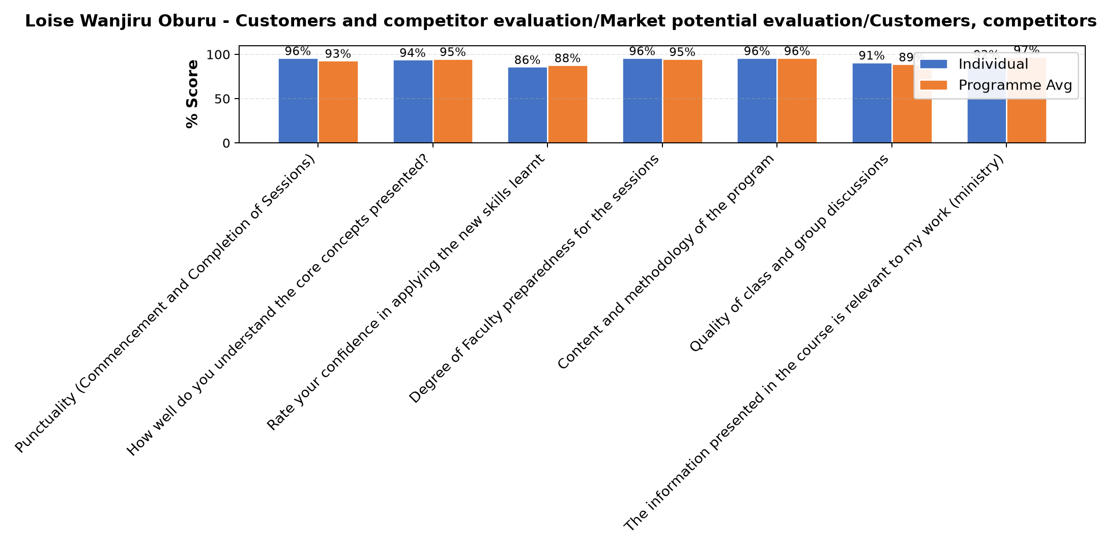

Comments & Feedback
- • May be the distance but I will make the effort to go for benchmarking
- • Ignorance
- • Internal administration challenges related to the project.
- • No barriers. What I have learnt is practical.
- • Lack of knowledge and skills
- • Delays in payment might prevent me from accomplishing the set targets on time and meet the objectives or goals ahead.
- • Ignorance of not exploring much more on our social enterprise
SUBMITTED THROUGH:
SBS Evaluation Automation System

